Use-Case Realization Report
Manage Error

Issue <1.0>
Revision History
Date | Issue | Description | Author
<15/may/11> | <1.0> | Initial Document | Koh Ming Jin

Table of Contents
1. Brief Description 4
2. Flow of Events 4
2.1 Standard Flow 4
2.2 Exception 4
3. Interaction Diagrams 4
3.1 Collaboration Diagram for Manage Error 4
4. Participating Objects 4
4.1 Error 4
4.2 Error Panel 4
5. Class Diagrams 5
5.1 Domain Class Diagram: Manage Error 5
6. Derived Requirements 5

Use-Case Realization Report
Manage Error

Brief Description
This use case enables an operation manager to manage error records. Managing error records includes creating, updating and deleting of error records. The required information includes the error ID, error name and error explanation.

Flow of Events
The standard flow of events for this use case and any exceptions are described in the following subsections. See section 3.1 for an overview of the participating Actors and Domain Objects.

Standard Flow
The flow of events is described as follows:

- The use case starts when Operation Manager selects the Manage Error option of the system.
- The Manage Error Panel is displayed.
- The Operation Manager provides all the required details concerning an existing error into the Manage Error Panel or selects the records which he/she wants to view from the Manage Error Panel.
- The existence of the error in the system is checked against the error information held by the database.
- If the error is in the current database and the selected option is to either delete or update,
  - The error record will be updated with the supplied details.
  - The error record will be deleted with the supplied details.
- If the error is no in the current database and the selected option is to create a new error record, the new error record will be created with the supplied details.
- The use case terminates.

Exception
- The error ID does not exist for update or delete option. If the input error ID is not found to be an existing one, the error modification or deletion will fail. An error message is displayed, and the Manage Error Panel is displayed again.

Interaction Diagrams

Collaboration Diagram for Manage Error
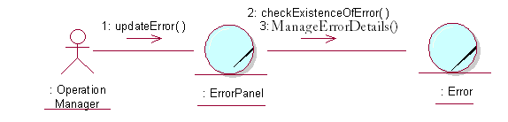

Participating Objects

Error
This object stores the details concerning the error of the COMS.

Error Panel
This screen is used to display error details, when an error record is created/ updated/ deleted. The Director, Department Manager and Operation Manager actors use this object.

Class Diagrams

Domain Class Diagram: Manage Error
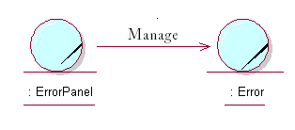

Derived Requirements
The Operation Manager PC keyboard and mouse will be used to enter error details (if any) and view all the system responses.

